

The mobile Application of Islamic Inheritance System

A PROJECT

PRESENTED TO THE FACULTY OF

COMPUTING

SIMAD UNIVERSITY

MOGADISHU, SOMALIA

IN PARTIAL FULFILLMENT OF THE REQUIREMENTS FOR THE DEGREE

BACHELOR OF COMPUTING IN COMPUTER SCIENCE

Mohamed Omar Abdullahi

Zakariye Ali Alim

March 2023

## Declaration

We hereby declare that this thesis, entitled the mobile Application of Islamic Inheritance System, is my original work, and it has not been submitted in part or in full for any other degree or qualification. All sources of information and materials used in this thesis have been duly acknowledged and cited.

We further declare that all the contributions and ideas presented in this thesis, whether directly or indirectly have been properly referenced. Any assistance received from individuals or institutions in the completion of this thesis has been acknowledged in the acknowledgements section.

We understand that any form of plagiarism or academic dishonesty strictly prohibited and that the submission of this thesis implies my adherence to the academic integrity policy of Simad University. We take full responsibility for any breaches of ethical conduct and intellectual property rights.

We acknowledge that my thesis may be subject to scrutiny and evaluation by the thesis committee and academic authorities. We am open to any corrections, revisions, or recommendations made by them to enhance the quality and accuracy of this work.

## Dedicate

We dedicate this thesis to my loving family, whose unwavering support and encouragement have been the driving force behind my academic journey. To our parents, thank you for instilling in me the values of perseverance and hard work. Your sacrifices and belief in my abilities have been a constant inspiration.

To our dear wives, We dedicate this thesis to you. Your unwavering love, patience, and understanding have been my rock throughout this demanding endeavor. Thank you for standing by my side and believing in me even during the most challenging times.

We would also like to dedicate this thesis to my supervisor, whose guidance, expertise, and support have been invaluable. Your dedication and mentorship have shaped my research and enriched my academic growth.

Finally, We dedicate this thesis to all the individuals who have been part of my academic journey, including our siblings, friends, and mentors. Your support, encouragement, and belief in our abilities have played a significant role in our success.

This thesis is a testament to the collective effort and unwavering support of these remarkable individuals. Thank you all for being a part of our journey and for inspiring me to reach new heights.

## Acknowledgements

We would like to express our deepest gratitude and appreciation to the following individuals, without whom the completion of this thesis would not have been possible.

First and foremost, we are immensely grateful to my supervisor, for their guidance, unwavering support, and valuable insights throughout the research process. Their expertise and dedication played a crucial role in shaping the direction of this work.

We are also indebted to my parents, for their endless love, encouragement, and sacrifices they made to ensure our education. Their unwavering belief in our abilities has been a constant source of inspiration.

We would like to extend my heartfelt appreciation to my brothers. Their unwavering support and motivation have been invaluable throughout my academic journey. Their encouragement and belief in us have been a driving force behind our success.

Last but certainly not least, we would like to express our deepest gratitude to our wives. their unwavering love, patience, and understanding have been our rock throughout the ups and downs of this thesis. Their encouragement and belief in our abilities have kept us focused and motivated.

To all these individuals, I offer our sincere thanks for their indispensable contributions and for being pillars of support in our academic pursuit. We are truly fortunate to have had such an incredible network of individuals surrounding us, and we are forever grateful for their presence in our lives.

## Abstract

This thesis presents a mobile-based application for Islamic inheritance calculation in accordance with Islamic teachings. The objective of this research is to create a practical and efficient app that simplifies property distribution, improves accessibility, and supports education and learning. The complexity of the inheritance calculation is discussed, leading to a lack of interest in studying the topic and misunderstandings among beneficiaries. The proposed system, Dhaxalxisaab, is developed using a Rule-Based System Algorithm to calculate the exact value of the inheritance portion and value in accordance with Islamic law. The app includes contain user theme, with a focus on protecting personal data confidentiality. The significance of the system lies in its potential to enhance students' understanding of Islamic inheritance and upgrade their potential to acquire basic university knowledge. The methodology of the proposed system is discussed, including the use of Android application and Firebase. A comparison of existing systems and the proposed system is presented. The research findings show that the proposed system is efficient, practical, and user-friendly, with potential for wider use. Overall, this research contributes to the development of systematic and productive software development paradigms for Islamic inheritance systems and calculators.

**Table of Contents**

Declaration ii

Dedicate iii

Acknowledgements iv

Abstract v

List of Tables ix

List of Figures x

CHAPTER ONE 11

INTRODUCTION 11

1.1 Introduction 11

1.2 Background of the project 11

1.3 Problem Statement 12

1.4 Research Questions 12

1.5 Purpose of the project 12

1.6 Objectives 12

1.7 THE SCOPE OF THE SYSTEM 13

1.8 Significance of the system 13

1.9 Project organization 13

CHAPTER TWO 14

LITERATURE REVIEW 14

2.1 INTRODUCTION 14

2.2 RELATED WORKS 14

2.3 EXISTING SYSTEMS 15

2.4 Comparison between Exiting and proposed system 19

2.5 GAP ANALYSIS 20

2.6 CHAPTER SUMMARY 20

Chapter three 22

3.1 Requirement Analyses 22

3.2 Introduction: 22

3.3 User requirements 22

3.4 Current system 22

3.5 UML 23

3.6 Preliminary Investigation: 24

3.7 Feasibility study 25

3.8 Purpose of system: 26

3.9 System requirement specification 28

3.10 Chapter summery 29

Chapter 4 30

DESIGN, CODING, IMPLEMENTATION, AND TESTING 30

4.1 Introduction 30

4.2 Architectural Design 30

4.3 Coding 33

4.5 Testing 33

4.6 Documentation 34

Chapter 5 36

Recommendation & Conclusion - Islamic Inheritance App 36

5.1 Introduction 36

5.2 Conclusion 36

5.3 Contribution 36

5.4 Limitations 36

5.5 Future Enhancements 37

5.6 Recommendations 37

Reference 38

|  |  |
| --- | --- |
| Authors: | Mohamed Omar Abdullahi |
|  | Zakariye Ali Alim |
| Program | Computer Science |
| Advisor | Eng. Abdulle Hassan Mohamud |

List of Tables

Table 1 Technical feasibility study 23

Table 2 Economical feasibility study 24

Table 3 Schedule feasibility study 24

Table 4 shows solution strategy 25

Table 5 Hardware interface 27

List of Figures

Figure 1 SMF calculation interface 15

Figure 2 SMF result interface 15

Figure 3 IFC Main Page 16

Figure 4 IFC Calculator page 17

Figure 5 AraFamOnto 18

Figure 6 Use case diagram of Islamic inheritance 22

Figure 7 Login screen 29

Figure 8 Registration screen 29

Figure 9 Heirs screen 30

Figure 10 Results screen 30

Figure 11 system test 51

## CHAPTER ONE

# INTRODUCTION

## Introduction

Mobile applications are consist of software/set of program that runs on a mobile device

and perform certain tasks for the user (Mazumder & Islam, 2018). Inheritance in Islam is property/funds (assets) transferred from a deceased family member to their loved ones (Sabit, 2015).

## Background of the project

Software has become an essential part of our daily activities, both personal and confessional, since the 1960s. However, until the mid-1970s, there was no specific paradigm for developing software in a systematic, reproducible, and highly productive manner. During the following decade, a powerful approach called the structured paradigm developed, which revolutionized software development.

(Alshahad et al 2015). Proposed an online Islamic Inheritance system (IIS) to calculate the shares of heirs. The system gathered all necessary information about the deceased and processed it through a decision table containing all rules of Islamic law for determining the portions. Similarly, other researchers, such as (Akkila et al. 2016), (Zulkifli et al. 2018), and (Zouaoui et al. 2018), proposed software systems for Islamic inheritance calculations. However, the mathematical expressions for computing the desired shares of live heirs of the deceased were not well-expressed enough for building a system.

(Babalola, 2017) presented mathematical expressions for computing the shares of legal heirs accurately. However, some of the equations, such as those for father, grandfather, and adjustment, were error-prone in certain situations. Thus, there was a need to correct these error-prone equations.

Additionally, several inheritance calculators have been developed, such as "Division of Inheritance," "ShariahStandards.org," "lubnaa.com," and "Uttaradhikar," among others. However, these calculators have limitations, such as the inability to differentiate between full, paternal, and uterine brothers and sisters, confusing front pages, and unclear ideas about siblings.

## Problem Statement

The science that studies the calculation of inheritance slowly being forgetting because calculating the amount of inheritance is quite complicated. This makes students less interested in studying this topic. One of the problems that occurs when practicing faraid among Muslims is that beneficiaries do not understand the concept of Faraid, which can lead to misunderstandings about Faraid distribution and narrow its application, making it unworkable. The distribution of properties solved using the Dart Programming Language and verified using the Inheritance Calculator Mobile Application. The findings indicate that all rules that has been tested are similar to manual calculations, showing that the algorithm works and the objective has been successfully achieved

## Research Questions

* + 1. Why inheritance calculation being forgotten, and how does it affect students?
    2. What problem arises when beneficiaries do not understand Faraid, and how can solved?
    3. How were technology solutions used to simplify property distribution, and what were the findings?

## 1.5 Purpose of the project

The purpose of this research is to design a Mobile Based Application for Inheritance Calculation of Islamic inheritance, Islamic Family Law Department, Sharia that is practical, effective and efficient.

## 1.6 Objectives

1. to provide access to important information of Islamic inheritance system
2. to Improving accessibility of Islamic inheritance system
3. to Support educational and learning of Islamic inheritance system

## 1.7 THE SCOPE OF THE SYSTEM

The scope of the project is that in a very short period of time it provides users with many facilities. The two main themes of the application are user and admin. We are both securely connected as volunteers, and third parties cannot access personal data.

## 1.8 Significance of the system

The significance of mobile technology to upgrade students' potential to acquire basic university knowledge and class content. With respect to their outcomes, mobile technology improvised students' understanding by uplifting the adequacy of staff to student, student to staff, student to student, and college to student interaction. Through this study, we may take a step to bridge the gap between the previous studies and the present studies by bringing out an in-depth analysis of this particular subject but in terms of growing technology and modern education system.

## Project organization

The content of this report arranged as follows:

Chapter 1: Provides an introduction and background about the problem facing the current system of Islamic inheritance. In addition to that, this chapter will cover the objectives, scope, and significance of this project, expected outcome and how the project is organized.

Chapter 2: Describes an overview of the project in detail, covering and discussing the relevant literature of Islamic inheritance systems.

Chapter 3: Explains how the data was collected, analyzed, and how the feasibility study was conducted. This chapter also describes how the questionnaire was done and the findings of the analyzed data.

## CHAPTER TWO

# LITERATURE REVIEW

## INTRODUCTION

To understand the Islamic laws of inheritance as a whole it is necessary to consider the system of inheritance that operated within the Arabian Peninsula prior to the revelation of the Qur’anic injunctions on inheritance. Although we do not have the exact details of the system that operated prior to the Qur’anic revelations, we do know that the system of inheritance was confined to the male agnate relatives (Asaba) of the deceased.

In this old customary system, only the male agnates (Asaba) were entitled to inherit. Amongst the male agnates, there were rules of priority, which determined which of the surviving male agnates were entitled to inherit. It is likely that the rules of priority that operate amongst the Asaba in Sharia are a carry-over of the old customary agnatic system (Yasir Billoo 2003).

In Islamic law, the son takes priority over the father who in turn takes priority over the brothers who in turn take priority over the paternal uncles. (Yasir Billoo 2003).

## RELATED WORKS

(Zuleika, A., & Desinthya, N.P. 2014), the article aims to increase awareness about the importance of Islamic law of inheritance for knowledge development and social prosperity. It employs a qualitative method and literature review to reveal the rules set in Faraid and their economic implications, as well as the hikmah (wisdom) behind the rules. The Faraid system ensures the redistribution of wealth and spreads the concentration of wealth in every generation. The article also aims to raise consciousness for being Sharia’ compliance by revealing the secret behind His rules and their benefits for humankind.

(Sabit, 2015), The aim of this system is to provide accurate calculation in the distribution of wealth, including various inputs such as cash, houses, land, insurance, etc. It uses a rule-based system algorithm, and its objective is to improve and complete the current system while educating Muslims on Faraid systems and their calculation. While the calculation is almost flawless, the system is not very user-friendly, and its target user is limited.

(Khosyi’ah, S & Irfan, Mohamad & Maylawati, Dian & Mukhlas, O. 2018), This research analyzes the knowledge of experts in Islamic inheritance in Indonesia and represents it in the form of rules using rule-based Forward Chaining (FC) and Davis-Putman-Logemann-Loveland (DPLL) algorithms. The aim of the study is to provide solutions by collecting information through the FC and DPLL algorithms. However, improvements are needed for the FC algorithm since there is no decision tree yet to facilitate the implementation of the rules, and the DPLL algorithm has not fully evaluated the satisfiability of every rule.

## EXISTING SYSTEMS

There is one system that already developed and similar to Islamic inheritance. The system is system Maklumat Faraid (SMF) which developed by lecturers from Universiti Sains Malaysia (USM). The developers are Prof Madya Dr Abd Rahni Mt Piah, Prof Madya Dr Ahmad Abd Majid and Prof Madya Dr Abdullah Embong. In figure 1 shows, "The results of the application can be printed immediately, in addition to displaying information on the faraid system and listing the heirs who are entitled to receive the deceased property," he said. Dr Ahmad said, SMF was produced with the help of last year students as well as a group of reference experts, including local scholars. (Berita Harian, 1998).

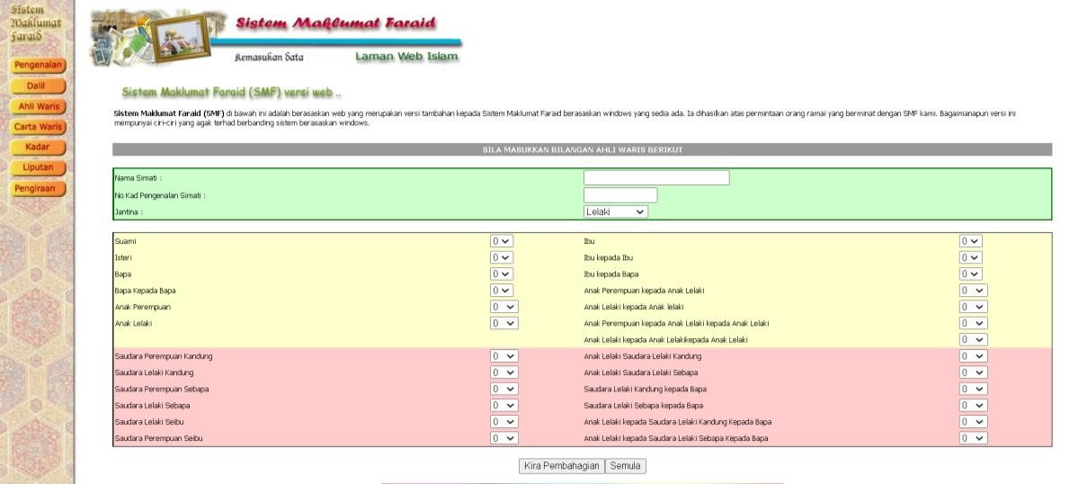

#### Figure 1 SMF calculation interface

Figure above shows one of the interface in SMF as web based system. Generally, users will input numbers of heirs who are still alive and few information’s about the deceased. However, the system only calculate the portion of the inheritance and did not include the inheritance value.



Figure 2 SMF result interface

As a justification, Dhaxalxisaab expected to calculate the exact value of the inheritance portion and value by following Islamic Inheritance law and using the technique Rule Based System Algorithm.

Another system that focus on Faraid science is Interactive Faraid Calculator (IFC) that was developed by Harith Hasyimi bin Hishamudin a student from Universiti Teknologi Petronas (UTP) in 2012. There is no denying that the details of the system are flawless, but some information was found to be unnecessary for the calculation such as date of the birth and the name of the deceased.

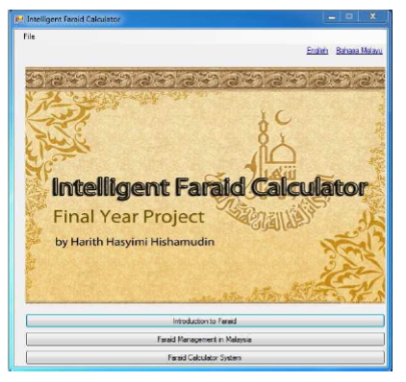

Figure 3 IFC Main Page

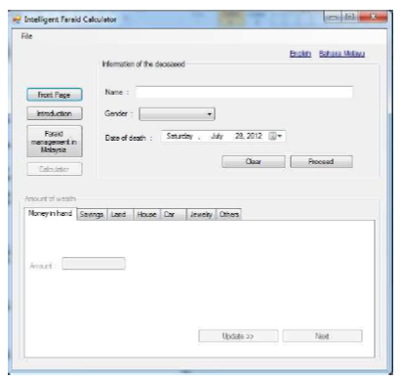

Figure 4 IFC Calculator page

Another system is AraFamOnto ontology is a manually created ontology that covers 50 families based on real-life relationships. It was created to support the development of an inheritance calculator that adheres to Islamic law. The ontology were created using Portege editor and Jena API and contains classes such as Person, Father, Mother, Husband, Wife, and Child. The ontology was used to automatically extract instances (individuals) from text files containing family members of each person. The inheritance calculator developed using AraFamOnto ontology allows users to input the name of the deceased person and calculate the inheritance shares of each heir in accordance with Islamic law.

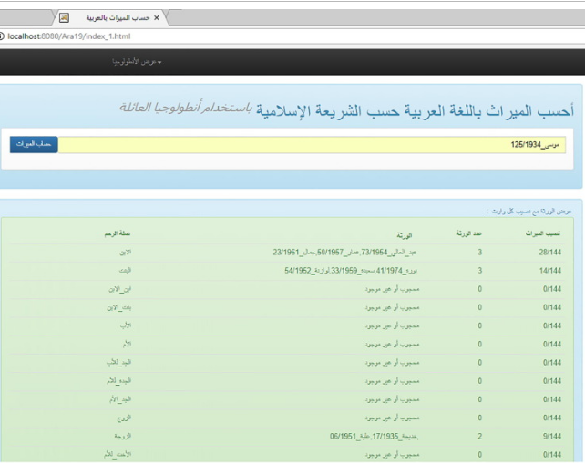

Figure 5 AraFamOnto

## Comparison between Exiting and proposed system

The SMF system is a web-based application developed by university professors to help calculate the percentage of each heir's share of an estate. It is designed to be simple and easy to use, with no login required and no save/edit features. Users simply input the number of heirs and information about the deceased, and the system calculates the percentage of each heir's share. This can be a useful tool for individuals or families who are managing an estate and need to distribute assets fairly among multiple heirs. The SMF system was developed using PHP, HTML, and CSS, which are common programming languages for web development. It is accessible from any device with an internet connection, making it easy to use on the go or from multiple locations. However, because it does not require users to log in or provide any personal information, it may not be the most secure option for sensitive estate planning needs (Berita Harian, 1998).

IFC is another web-based application designed to help calculate the percentage of each heir's share of an estate. Unlike SMF, IFC uses HTML, CSS, and JavaScript for development. It was developed by a university student and does not require users to log in or provide personal information. The system is easy to use and provides a quick calculation of each heir's share based on the number of heirs and information about the deceased (Zuleika, A., & Desinthya, N.P. 2014).

Dhaxalxisaab is a mobile application developed by a university student that requires users to log in and input information about the deceased and number of heirs in order to calculate the percentage and value of each heir's share of the estate. This system has a save/edit feature, which can be useful for individuals or families who need to adjust their estate plans over time. The system was developed using Dart, which is a programming language commonly used for mobile app development.

## GAP ANALYSIS

|  |  |  |  |  |  |  |  |
| --- | --- | --- | --- | --- | --- | --- | --- |
| System Name | Web-based | Mobile App | Login Required | Calculate Heirs Share | Calculate Value | Save/Edit Feature | Printable |
| SMF | Yes | No | No | Yes | No | No | Yes |
| IFC | Yes | No | No | Yes | No | No | No |
| AraFamOnto | Yes | No | No | No | Yes | No | Yes |
| Dhaxalxisaab | No | Yes | Yes | Yes | Yes | Yes | Yes |

## CHAPTER SUMMARY

the main point we will explain this chapter introduction, literature review, definition of inheritance, related work, rights related to the deceased comparing with existing system and proposed system, methodology of proposed system which is android application and firebase and last comparison is existing system new system.

# **CHAPTER THREE**

## Requirement Analyses

## Introduction:

In this chapter we are discussing how we conducted the system analysis, feasibility study and provide a graphical representation of overall functionality of the system using UML diagrams. We also state the problem we are trying to solve

## User requirements

A good set of user requirements needed for any project, especially computer system Projects to be successful.

#### Heirs

1. To be able to Login the system.
2. To be able to create new account.
3. To be able to input heirs includes husband or wife, son, daughter, etc.
4. To be able to view and print their information.

## Current system

The current system we are trying to convert from is a manual system that uses to calculate all data about decease and heirs in a file. They either use an excel document or a word to store information.

#### Limitations of current system

1. It is time consuming.
2. It leads to error prone results.
3. It lacks of data security.
4. Percentage of accuracy is less.
5. Reports take time to produce.

## UML

Unified modeling language (UML) is standardized modeling language enabling developers to specify, visualize, construct and document artifacts of a software package. Thus, UML makes these artifacts ascendible, secure and sturdy in Execution.

#### Use case Diagram

is a methodology used in system analysis to spot, clarify and organize system needs during this context, the term ―system ― refers to one thing being developed or operated, such as a mail – order product sales and repair use case diagram are used UML (uniform modeling language), a standard notation for the of real-world objects and system.

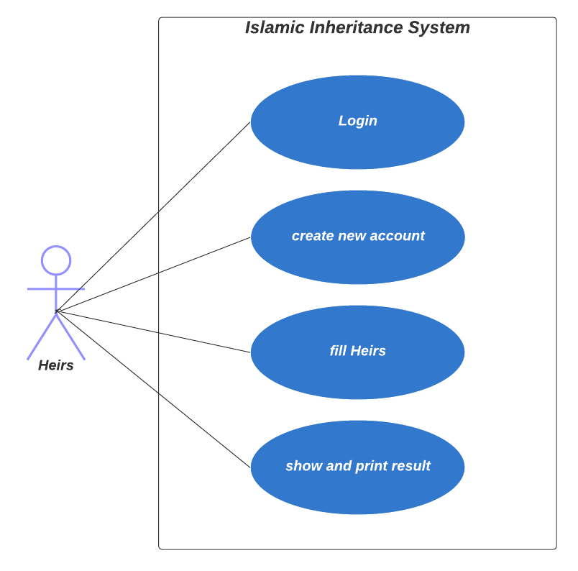

Figure 6 Use case diagram of Islamic inheritance

## Preliminary Investigation:

First in the system, development process is preliminary Investigation. Preliminary Investigation conducted to justify the work that done. It answers questions such as is the system being developed suitable to the environment that being developed. We have answers all questions required from our system.

For the development team they need to have:

1. A pc with Intel core i5 or later, running windows 10.
2. Android studio.
3. API keys for accessing the firebase database.

## Feasibility study

The feasibility study performed to determine whether the proposed system is viable considering the Technical, Operational and Economical factors. After going through feasibility study, we can have a clear-cut view of the system’s benefits and drawbacks.

#### Technical feasibility study

The proposed system developed using Java programming Language for android development, Android studio as front-end tool and Google’s Firebase database as the back end. The proposed application needs to install on the user’s phone to able to use it. Users can install it from Google drive or they can get as an apk file. For normal users all required from them is that they have a smart phone.

|  |  |  |  |  |  |
| --- | --- | --- | --- | --- | --- |
| Table 1 Technical feasibility study | | | | | |
| NO | Name | Description | Quantity | Unit price | Total | |
| 1 | Pc | HP cori5, ram  8 | 2 | 400 | 800 | |
| 2 | Window10 | 64 bit | 3 | 3 | 6 | |
| 3 | Model | Wireless | 1 | 30 | 30 | |

#### Economic feasibility study

Economic practicability analysis is that the most ordinarily used methodology for decisive the potency of a brand new project. It’s additionally called analysis. It helps in characteristic profit against investment expected from a project. Price and time are the foremost essential factors concerned during this field of study.

|  |  |
| --- | --- |
| Table 2 Economical feasibility study | |
| Name | Cost |
| Technical | $25/ per month(firebase pricing) |
| Operational | $150 |
| Development cost | 0 $ |
| Total | 175$ (changeable) |

#### Schedule feasibility study

|  |  |  |  |  |
| --- | --- | --- | --- | --- |
| Table 3 Schedule feasibility study | | |  |  |
| Level | Phase Name | Start | Finish | Duration(weeks) |
| 1 | Analysis phase | 4/3/2023 | 18/3/2023 | 2 weak |
| 2 | Design phase | 19/3/2023 | 1/4/2023 | 2weeks |
| 3 | Coding | 2/4/2023 | 2/5/2023 | 4 weeks |
| 4 | Implementation, testing | 3/5/2023 | 17/5/2023 | 2 week |

## Purpose of system:

The purpose of the app is to educate users about Islamic inheritance so that they have a better understanding about the distribution of wealth in Islam. It also helps users:

#### Goals of proposed system:

1. To determine the portions of the distributed wealth with the app’s calculator.

2. To reducing the tendency of family disputes among them.

3. Being a mobile app, it can be used anywhere and anytime without having to connect to the internet.

4. The app is able to calculate the distribution of wealth to those who have the rights or entitled to receive their portion of the wealth.

#### User characteristics

User of the application are required to have the following elements:

* A smart phone
* internet access or local area Network
* Must know how to use how an app.
* He should know about the people in the way they inherit the property or have knowledge about the Islamic inheritance

#### Constraints

There are some constraints that can face the users and they are:

* The user must have username and password before access the system
* Some functionality may not work if users do not have internet access.

#### Solution strategy

For developing this system, there are a lot of optional that we can use

|  |  |  |
| --- | --- | --- |
| Table 4 shows solution strategy | |  |
| Option one | Android and firebase | Best option |
| Option two | Android and mysql | Best option |

Option one

We used on option one to develop this system android Front end

* Xml (designing and interface)
* Android (java code)

Back end

* Google firebase with dash board to analyze data.
* Database

Front end selection advantages

* High security
* Good performance
* User friendly
* accessibility

Back end selection advantages

* Reliable database (any time & any place) because it’s based on cloud.
* Data security

## System requirement specification

#### System interface

The system must be very easy and friendly. For users a candidate must register them before they are able to be logging app. However, they must specify and fill some requirements such as decease gender and number of heirs.

#### User interface

The user interface must be very clean and simple. There must be some guide and instruction that tell the users what to do.

#### Hardware interface

|  |  |
| --- | --- |
| Table 5 Hardware interface | |
| Server | Client |
| Table, smartphone. | Tablet, smartphone |

## Chapter summery

In this chapter we discussed the user requirements, feasibility study and over all description of the system. We also provided the problem that we are trying to solve, how we will solve it and how our app will help our society. We provided how our system works with the help of UML diagram such as use cases and sequence diagrams. This chapter was the foundation of our app so we took care of it very carefully.

# CHAPTER FOUR

## DESIGN, CODING, IMPLEMENTATION, AND TESTING

## 4.1 Introduction

This chapter focuses on the design, coding, implementation, and testing stages of the Islamic inheritance app. These stages are crucial in ensuring the functionality and usability of the application. The chapter provides an overview of the process involved in developing and refining the app, including the design considerations, coding practices, implementation steps, and testing procedures.

## 4.2 Architectural Design

To create a user-friendly experience, it is essential to use consistent controls and interactions throughout the Islamic inheritance app. The navigation and user interface elements should be intuitive and accessible to all users. In the case of low vision users, adapting controls to meet their specific requirements becomes important. This may involve modifying existing controls or creating new ones tailored for visually impaired users. The goal is to ensure that the app is easy to navigate and understand for individuals with visual impairments.

The following examples illustrate the simple and accessible design of the application:

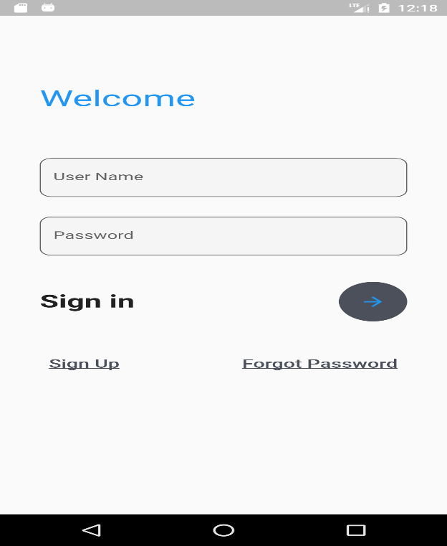

Figure 7 Login screen

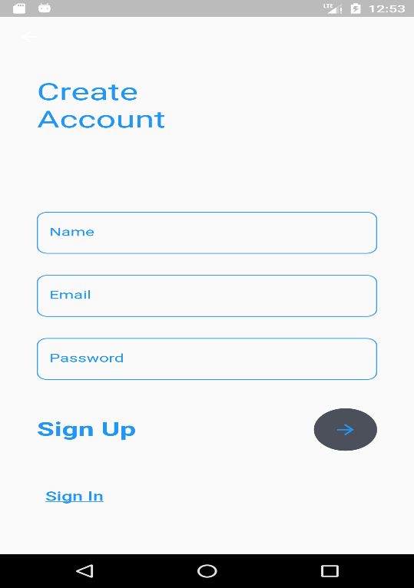

Figure 8 Registration screen

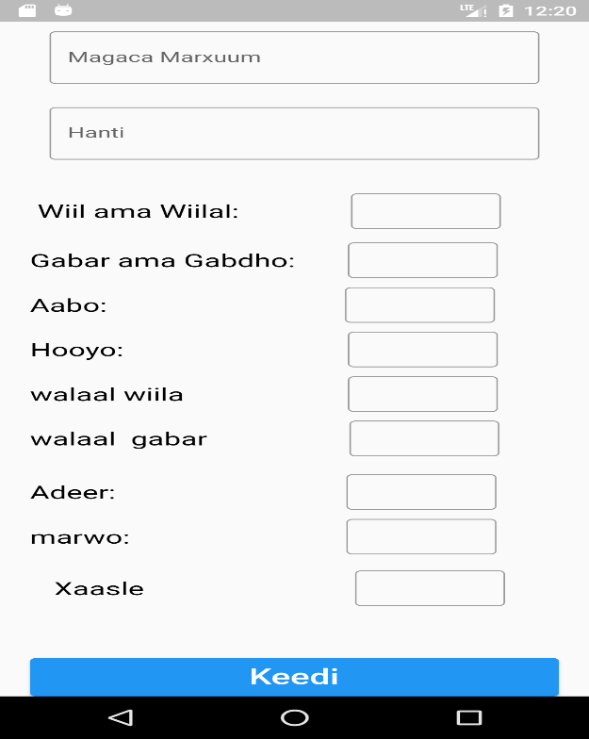

Figure 9 Heirs screen

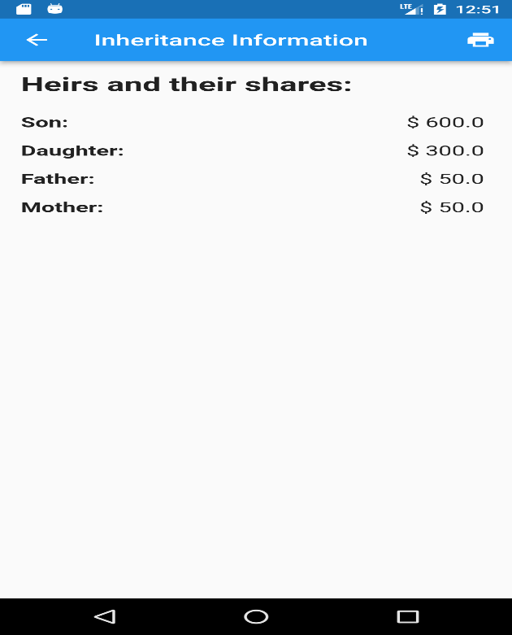

Figure 10 Results screen

#### 4.2.1 Design Goals

During the application design part, there are several aspects to think about within the application considering the users are people with visual imparity. Some of these goals are:

• Adaptable: The user should understand the application without any instruction manual since the users are visually impaired.

• User friendly: Software that is simple to use, comprehend, or deal with is also a user-friendly environment that is acceptable and engaging.

• Reliability: The system is prepared to carry out a necessary task under specified circumstances for a predetermined period.

• Minimal actions: The application should be minimal using less complex design like too many buttons and confusing objects.

## 4.3 Coding

The Islamic inheritance app is developed using the Flutter framework. The codebase consists of several classes and modules that work together to implement the desired functionalities. Here are the main classes used in the app:

class Heir {

  final String name;

  double share;

  Heir(this.name, this.share);

  Heir updateShare(double newShare) {

    return Heir(name, newShare);

  }

}

List<Heir> calculateIslamicInheritance(

    double estateValue,

    double son,

    double daughter,

    double wife,

    double brother,

    double sister,

    double father,

    double mother,

    double uncle,

    double husband) {

  final List<Heir> heirs = [

    Heir('Son', son),

    Heir('Daughter', daughter),

    Heir('Wife', wife),

    Heir('Brother', brother),

    Heir('Sister', sister),

    Heir('Father', father),

    Heir('Mother', mother),

    Heir('Uncle', uncle),

    Heir('Husband', husband),

  ];

  // Remove heirs with zero shares

  heirs.removeWhere((heir) => heir.share == 0);

  // Calculate total shares

  double totalShares = heirs.fold<double>(0, (prev, curr) => prev + curr.share);

  // If total shares are less than 1, add the remaining share to the closest male relative

  if (totalShares < 1) {

    Heir maleRelative = heirs.firstWhere(

      (heir) =>

          heir.name == 'Son' ||

          heir.name == 'Brother' ||

          heir.name == 'Father' ||

          heir.name == 'Uncle' ||

          heir.name == 'Husband',

      orElse: () => Heir('', 0),

    );

    if (maleRelative != null) {

      maleRelative = maleRelative.updateShare(maleRelative.share + (1 - totalShares));

      totalShares = 1;

    }  }

  // Adjust shares proportionally if total shares exceed 1

  if (totalShares > 1) {

    heirs.forEach((heir) {

      heir.share = heir.share / totalShares;

    });

    totalShares = 1;

  }

  // Calculate inheritance for each heir

  final List<Heir> inheritance = [];

  heirs.forEach((heir) {

    double amount = double.parse((estateValue * heir.share).toStringAsFixed(2));

    inheritance.add(Heir(heir.name, double.parse((amount.toStringAsFixed(2)))));

  });

  return inheritance;

}

## 4.5 Testing

Software testing is a crucial part of ensuring the quality and reliability of the Islamic inheritance app. Through various testing techniques, potential issues and bugs can be identified and addressed.

4.5.1 The testing phase includes the following types of testing:

The testing phase contains three phases that are unit testing, integration testing and system testing.

#### 4.5.1.1 Unit Testing

Unit testing involves testing individual components, functions, or modules of the application in isolation. It helps ensure that each part of the app functions correctly and produces the expected results.

#### 4.5.1.2 Integration Testing

Integration testing focuses on testing the interaction and integration between different components or modules of the Islamic inheritance app. It verifies that the app functions as a cohesive unit when all the parts are combined.

4.5.1.3 System Testing

After the integration testing is finished, the full information will be tested as part of the system test. A system test covers every common processing scenario and is meant to reassure consumers and engineers.

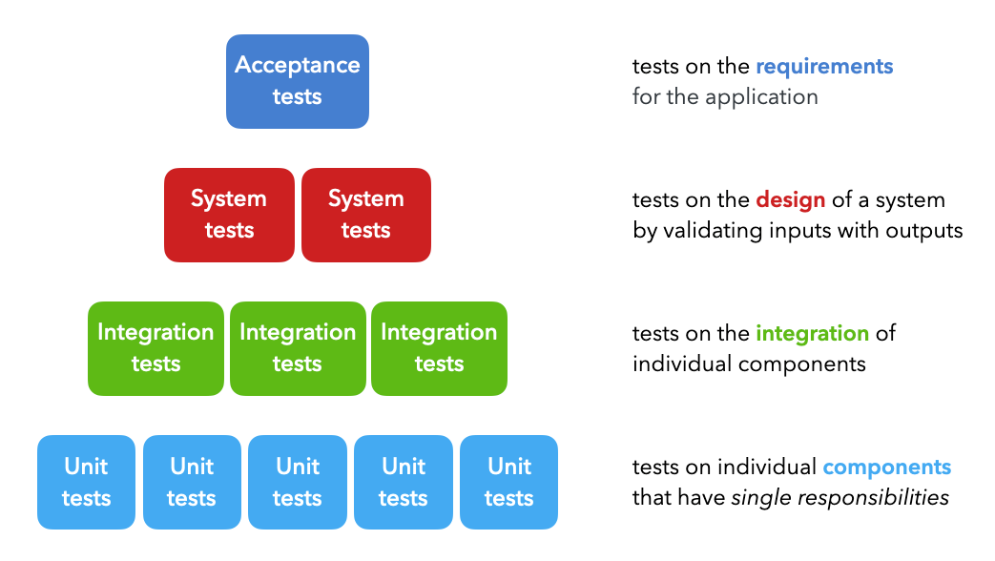

Figure 11 system test

## 4.6 Documentation

An information system's documentation provides information about it and aids users who must interact with it. Accurate documentation may speed up maintenance tasks, lower costs, and minimize system downtime. For successful system operation and maintenance, documentation is crucial. Accurate documentation is crucial for developers who must update a system, add new features, or do maintenance in addition to helping users.

The documentation that we conducted is written in the README file and it contains all the necessary information related to the documentation of the application.

# CHAPTER FIVE

## RECOMMENDATION & CONCLUSION - ISLAMIC INHERITANCE APP

## 5.1 Introduction

This chapter presents the recommendations and conclusions for the Islamic inheritance app project. It summarizes the project's goals and outlines how the app fulfills those objectives. Additionally, it reflects on the lessons learned during the development process and provides long-term suggestions for further enhancing the app's functionality in the context of Islamic inheritance.

## 5.2 Conclusion

The Islamic inheritance app utilizes advanced algorithms and principles derived from Islamic teachings to provide accurate and efficient calculations of inheritance shares. By employing a trained model and incorporating Islamic inheritance rules, the app reduces computational costs and processing time. The app allows users to input relevant information and generates precise inheritance distribution results according to Islamic principles. The inclusion of comprehensive guidance and references enhances user confidence in the app's accuracy and reliability.

## 5.3 Contribution

The creation of a user-friendly Islamic inheritance software helped the initiative achieve its goals. The following are important contributions:

1. Creating a user interface that is simple to use and accessible to users looking for information about Islamic inheritance.

2. Using algorithms precisely determine inheritance portions in accordance with Islamic law.

3. Including a thorough database of legal standards and references to guarantee dependability and openness.

4. Teamwork among project participants in developing and improving the application.

## 5.4 Limitations

While the Islamic inheritance app offers significant benefits, it is essential to acknowledge its limitations:

1. The app assumes accurate and complete input data. Inaccurate or missing information may lead to erroneous results.

2. Complex cases involving unique circumstances or unconventional family structures may require further legal consultation beyond the app's scope.

## 5.5 Future Enhancements

To further improvement the Islamic inheritance app, the following enhancements recommended:

1. To enhance the security of the system to protect the privacy and confidentiality of sensitive information related to inheritance planning and distribution in accordance with Islamic law.
2. To add features related to Islamic financial instruments, such as facilitating investments in accordance with shariah-compliant principles, and providing access to zakat-eligible charities for distribution of inheritance funds.
3. To extend the scope of the project to include other legal matters related to Islamic law, such as estate planning and family law.
4. To add features for online purchases of halal (permissible) goods and services, such as religious books, household items, and travel accommodations for pilgrimages to Mecca.

## 5.6 Recommendations

In light of the significance of Islamic inheritance, it recommended that more applications and resources developed to cater to the needs of individuals seeking guidance in this field. Addressing the information gap and providing accessible tools for calculating Islamic inheritance shares will benefit the Muslim community at large. Furthermore, collaboration between Islamic scholars, legal professionals, and developers can contribute to the ongoing improvement and development of such applications to ensure accuracy and adherence to Islamic principles.

## REFERENCE

Akriy, A. S., (1421 A.H). Madlabul-Nashidi: Sharhu Faradu Risalati ibn Abi Zaid Al- Qairawaaniy, Kano: Alh. Dahiru Mustapha Sagagi Publishers, pp.3-16.

Ali, S. H., (2003), Almirath: Justice of Islam in the rules of Inheritance, Pakistan: Al-Maktabah Al-Muhammedia Ghullah Mandi Publishers, pp. 15-39.

Bukhari, A. N., (2004). Inheritance in Islam, Al-Madinah Al-Munawwarah:

Al-Rasheed Printers, pp. 8-23.

Fibonacci, L. B., (2008). Fibonacci's De practica geometrie. Springer:

Munez Publishers, pp. 12.

Gandz, S. M., (1938). The Algebra of Inheritance: A Rehabilitation of Al-Khuwarizmi, University of Chicago Press, pp. 19-91.

Hussain, D.A., (2003). Islamic Laws of Inheritance (Online) Available: Islam101.com/inheritance" <http://www.islam101.com/inheritance> Dated (25th July 2023).

Keffi, U. D., (1990). Some Aspects of Islamic Law of Succession, Kano: Rukhsa Publications, pp. 4-76.

Livio, M., (2003). The Golden Ratio, New York: Broadway Publishers, pp. 90-96. Mazumder, T. A., & Islam, D. M. R. (2018). Mobile Application and Its Global Impact. International Journal of Engineering & Technology IJET-IJENS, 06, 72–78.

Sabit, M. T. (2015). The Contemporary Application of Wasiyah (Muslim Will) In Malaysia. International Journal of Real Estate Studies, 9(1), 8–15.

Zuleika, A., & Desinthya, N.P. (2014). Islamic Inheritance Law (Faraid) and Its Economic Implication. Tazkia Islamic Finance and Business Review, 8.

Khosyi’ah, S & Irfan, Mohamad & Maylawati, Dian & Mukhlas, O. (2018). Analysis of Rules for Islamic Inheritance Law in Indonesia Using Hybrid Rule Based Learning. IOP Conference Series: Materials Science and Engineering. 288. 012133. 10.1088/1757-899X/288/1/012133.